Movie Streaming Platform – SQL Project Report
Introduction:
This project models a Movie Streaming Platform using MySQL. It includes tables for users, subscriptions, movies, actors, watch history, and payments. The objective is to manage and analyze data effectively using SQL queries.
Database Design:
- Users – Stores user details and subscription IDs.
- Subscriptions – Stores plan name, price, and duration.
- Movies – Contains movie details such as title, genre, language, release year.
- Actors – List of actors.
- Movie_Actors – Many-to-Many mapping between movies and actors.
- Watch_History – Records user watch activities and ratings.
- Payments – Stores user payments and methods.
Dataset Description:
- 20 Users (with subscription info)
- 20 Movies (across genres & languages)
- 15 Actors
- 20 Watch History Records- 20 Payments
SQL Queries and Explanations:
Problem Statement :The query retrieves a list of all users along with the subscription plan they are enrolled in. It joins the Users table with the Subscriptions table to match each user to their corresponding plan.
1.List all users with their subscription plan names
SELECT u.name, s.plan_name FROM Users u JOIN Subscriptions s ON u.subscription_id = s.subscription_id;

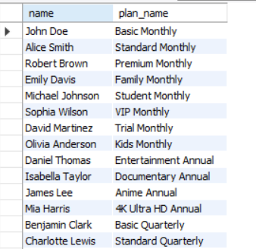

Problem Statement :The query is used to list all movies released after the year 2015. It filters the Movies table based on the release_year column and returns only the movie title and its release year.
- Show all movies released after 2015
SELECT title, release_year FROM Movies WHERE release_year > 2015;

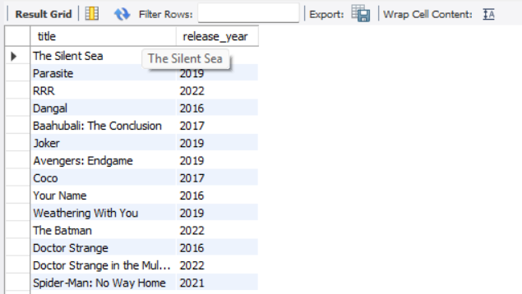

Problem Statement : The query retrieves all movies that belong to the Action genre. It filters the Movies table by the genre column and returns the movie title along with its genre.

- Find all movies in the 'Action' genre
SELECT title, genre FROM Movies WHERE genre = 'Action';
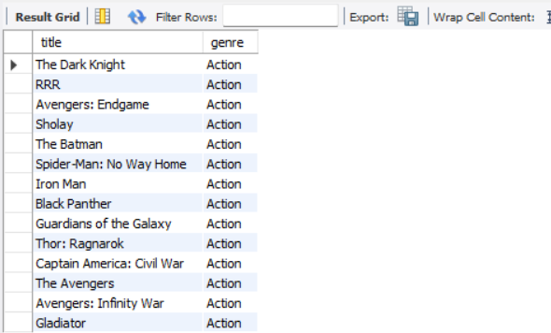
Problem Statement : The query lists all users who joined the platform during August 2023. It filters the Users table by the join_date column within the specified date range and returns each user’s name along with their join date.

--4. Get the names of users who joined in August 2023
SELECT name, join_date FROM Users WHERE join_date BETWEEN '2023-08-01' AND
'2023-08-31';
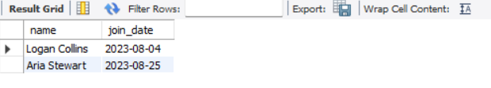
Problem Statement :The query retrieves all movies watched by the user Alice Smith. It joins the Watch_History, Users, and Movies tables to match the user with their watch history and return the corresponding movie titles.

--5. Retrieve the titles of movies watched by user 'Amit Sharma'
SELECT m.title FROM Watch_History w JOIN Users u ON w.user_id = u.user_id JOIN
Movies m ON w.movie_id = m.movie_id WHERE u.name = 'Amit Sharma';

Problem Statement :The query finds the total number of movies watched by each user. It joins the Users and Watch_History tables, counts the movies watched per user, and returns the user’s name along with their total watch count.

6. Count how many movies each user has watched
SELECT u.name, COUNT(w.movie_id) AS total_movies_watched FROM Users u JOIN
Watch_History w ON u.user_id = w.user_id GROUP BY u.name;
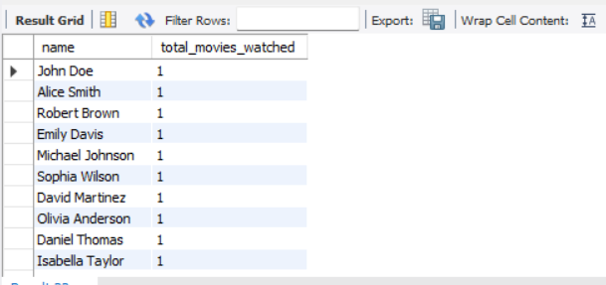
Problem Statement :The query calculates the average movie rating given by each user. It joins the Users and Watch_History tables, computes the average rating per user, and returns the user’s name along with their average rating.

7. Find the average rating given by each user
SELECT u.name, AVG(w.rating) AS avg_rating FROM Users u JOIN Watch_History w ON
u.user_id = w.user_id GROUP BY u.name;
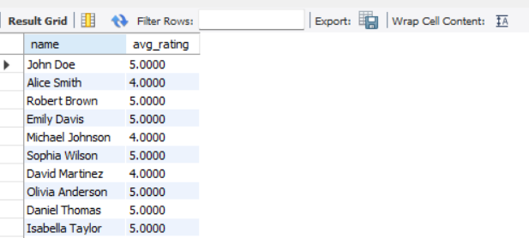
Problem Statement: The query retrieves the top 5 highest-rated movies on the platform. It joins the Movies and Watch_History tables, calculates the average rating for each movie, and returns the movie title with its average rating, sorted in descending order.

8. Get the top 5 highest-rated movies
SELECT m.title, AVG(w.rating) AS avg_rating FROM Movies m JOIN Watch_History w ON
m.movie_id = w.movie_id GROUP BY m.title ORDER BY avg_rating DESC LIMIT 5;

Problem Statement : The query lists all movies along with their actors. It joins the Movies, Movie_Actors, and Actors tables to match each movie with its cast and returns the movie title with the corresponding actor names, ordered by movie title.

9. List movies along with the actors who acted in them
SELECT m.title, a.name AS actor_name FROM Movies m JOIN Movie_Actors ma ON
m.movie_id = ma.movie_id JOIN Actors a ON ma.actor_id = a.actor_id ORDER BY m.title;
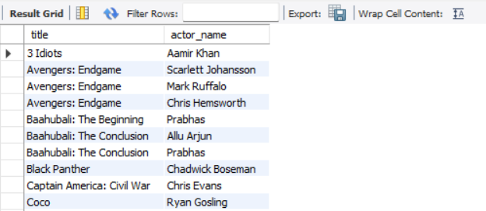
Problem Statement : The query calculates the total revenue generated by each payment method. It groups the Payments table by the method column and sums up the amount for each method to show how much revenue came from each payment type.
10. Find the total revenue collected by each payment method
SELECT method, SUM(amount) AS total_revenue FROM Payments GROUP BY method;

Problem Statement : The query identifies the most-watched movie genre on the platform. It joins the Watch_History and Movies tables, counts the total watches for each genre, and returns the genre with the highest number of views.

11. Find the most popular genre (watched the most times)
SELECT m.genre, COUNT(*) AS total_watches FROM Watch_History w JOIN Movies m ON
w.movie_id = m.movie_id GROUP BY m.genre ORDER BY total_watches DESC LIMIT 1;
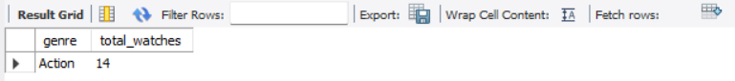

Problem Statement :The query retrieves the top 3 users who have spent the most on subscriptions. It joins the Users and Payments tables, sums the total payment amount for each user, and returns the user’s name along with their total spend, sorted in descending order.

12. Get the top 3 users who spent the most money on subscriptions
SELECT u.name, SUM(p.amount) AS total_spent FROM Users u JOIN Payments p ON
u.user_id = p.user_id GROUP BY u.name ORDER BY total_spent DESC LIMIT 3;
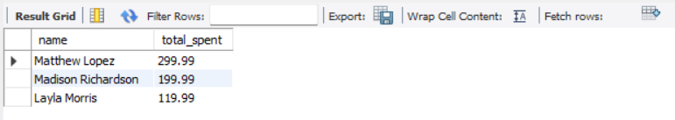
Problem Statement :The query lists all users who have never given a rating below 4. It checks the Watch_History table for ratings less than 4 and returns the distinct names of users who do not appear in that set.

13. Find users who have never rated a movie less than 4
SELECT DISTINCT u.name FROM Users u WHERE u.user_id NOT IN (SELECT user_id FROM
Watch_History WHERE rating < 4);
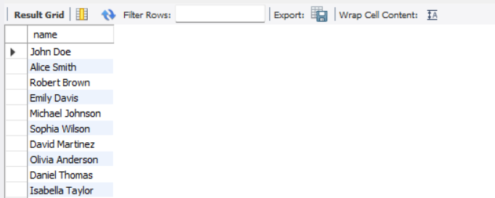

Problem Statement :The query retrieves movies that have been watched by at least 5 unique users. It joins the Movies and Watch_History tables, counts the number of distinct users per movie, and returns the movie title along with the count of unique viewers.

14. Show movies watched by at least 5 different users
SELECT m.title, COUNT(DISTINCT w.user_id) AS unique_users FROM Movies m JOIN Watch_History w ON m.movie_id = w.movie_id GROUP BY m.title HAVING COUNT(DISTINCT w.user_id) >= 5;

Problem Statement :The query finds each user’s most-watched movie genre. It joins the Users, Watch_History, and Movies tables, counts how many movies each user has watched per genre, and returns the genre(s) with the highest watch count for each user.

15. List users and their most-watched genre
SELECT u.name, m.genre, COUNT(*) AS watch_count FROM Users u JOIN Watch_History w ON
u.user_id = w.user_id JOIN Movies m ON w.movie_id = m.movie_id GROUP BY u.name,
m.genre HAVING COUNT(*) = (SELECT MAX(cnt) FROM (SELECT COUNT(*) AS cnt FROM Watch_History w2 JOIN Movies m2 ON w2.movie_id = m2.movie_id WHERE w2.user_id =
u.user_id GROUP BY m2.genre) AS subquery);
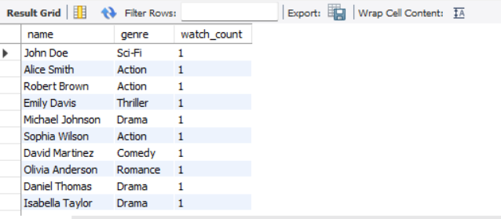

Conclusion:
This SQL project demonstrates how databases power streaming platforms by managing users, subscriptions, payments, and watch history. Using SQL queries, we analyzed user activity, movie ratings, and revenues. This project can be extended with dashboards and machine learning for recommendations.

